Packet tracer guide

You will need to download the Packet Tracer software from the Cisco Website. If you have a Cisco academy login already you can log in using your normal username.
First, you need to enrol on a packet tracer course to be able to get free access to the software. This can be done on the following link:
https://www.netacad.com/courses/packet-tracer/introduction-packet-tracer
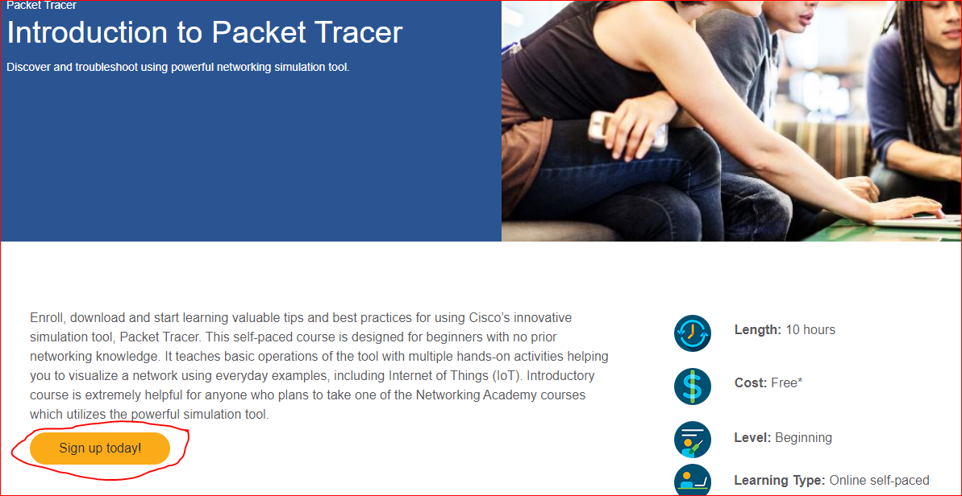
Once you have enrolled, login in in your “netacad space”. You can then download the software in “Resources” and “Download Packet Tracer”, install the software.
The following instructions will help you to get started with Packet Tracer. Remember you can also consult the tutorials and other usage help via the Help menu in Packet Tracer.
We are going to create a 2 router network shown in the diagram below 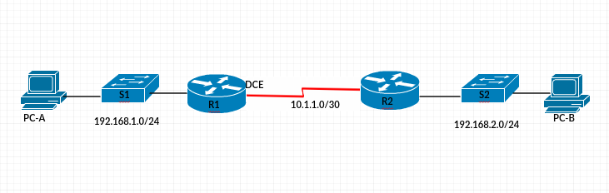

You need to put the required devices on the PT workspace. These can be found in the bottom left corner.
The 1st item opens the network devices including routers and switches. The second item opens the end devices including routers and servers.
If you click on the “Network Devices” and then the 1st icon “routers”

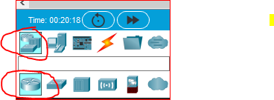
From the list of routers on the right, choose “PT-Router”, drag and drop the router on the workspace. Drag and drop as second router.

Go back on the network devices and choose the second icon “Switches” and out two PT-Switches on the workspace.

You can move the object by click and hold and dragging them to the desired location.

To rename the devices, click on the device name once, which will make the name editable and you can change it to the desired name.
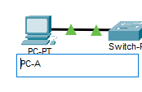
You also need two PCs, these can be found in the end devices menu
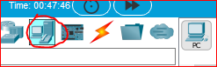

Choose PC and drag 2 to the workspace. You can rename them as explained above.

You now need to cable your network. The cables can be found in the “Connections”. There are several cables available.

For PC-to-Switch connection, choose straight-through cable

To connect the PC to the switch, 1st click on the cable, which will change the icon to the one shown in the figure below
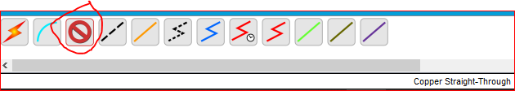
Once this is highlighted, click once on the PC, different options will appear as show below, choose “FastEthernet0”.
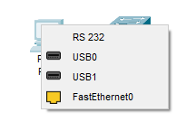
Next click once on the switch and choose “FastEthernat0/1”
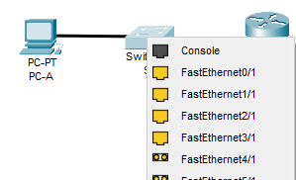
This will establish a connection between the PC and the switch.
Connect the switch and router using the same process.

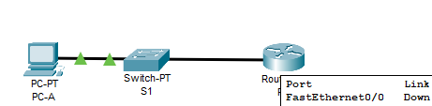

Note: Please note the names of your router’s interfaces. In this example, the interface is FastEthernet0/0
Follow the same process to connect the other side.
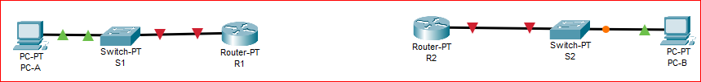
In order that routers can communicate between each other a serial port card must be installed on the router using the following steps
- Click on the router icon on your workspace
- In the new window that opens up select the physical tab
- Switch the router off by clicking on the button on the image of the routers facia
- Click on the HWIC-2T option on the left of the panel and drag this across to the card port on the RHS of the router facia.
- Switch back on the router
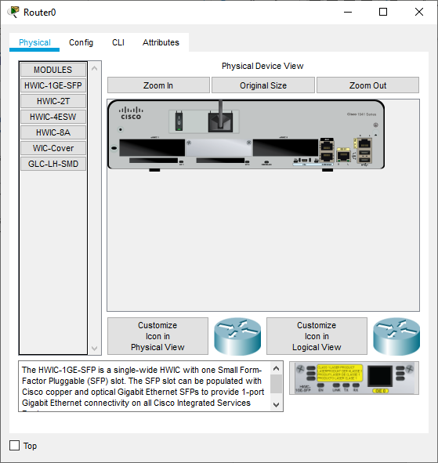
4 drag HWIC-2T icon to interface card port
3 switch off router
5 switch on router
2. Physical tab

To connect the two routers together, go back on the main connections menu and choose the lightning cable
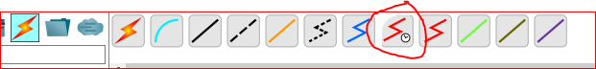
Once selected, click on the 1st router and select Serial 2/0, again please note the name of the interface
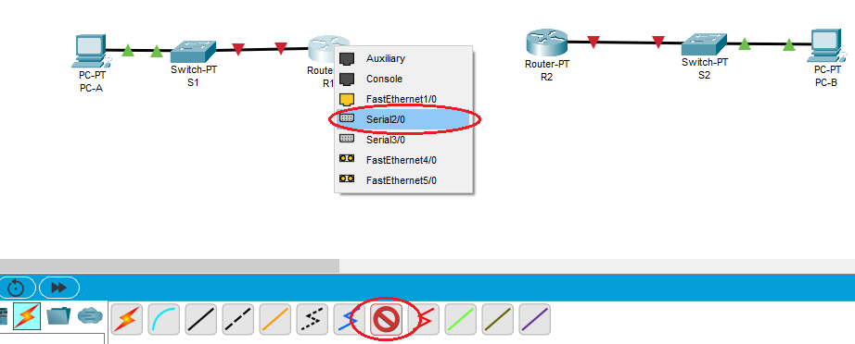
Now click on the other router and choose Serial2/0. Please note that the router you clicked on 1st is now the DCE and will have the clock rate set up.

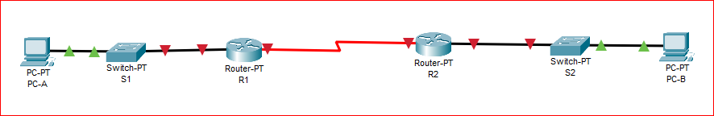

Let’s now proceed with the configuration of the devices using the IP addressing in the table below:
IP Addressing Table
Device | Interface | IP Address | Subnet Mask | Default Gateway
R1 | F0/0 | 192.168.1.1 | 255.255.255.0 | N/A
 | S2/0 (DCE) | 10.1.1.1 | 255.255.255.252 | N/A
R2 | S2/0 | 10.1.1.2 | 255.255.255.252 | N/A
 | F0/0 | 192.168.2.1 | 255.255.255.0 | N/A
PC-A | NIC | 192.168.1.2 | 255.255.255.0 | 192.168.1.1
PC-C | NIC | 192.168.2.2 | 255.255.255.0 | 192.168.2.1

Click on “R1”, this will open the router configuration menu as shown below. Take a moment to explore the interface.

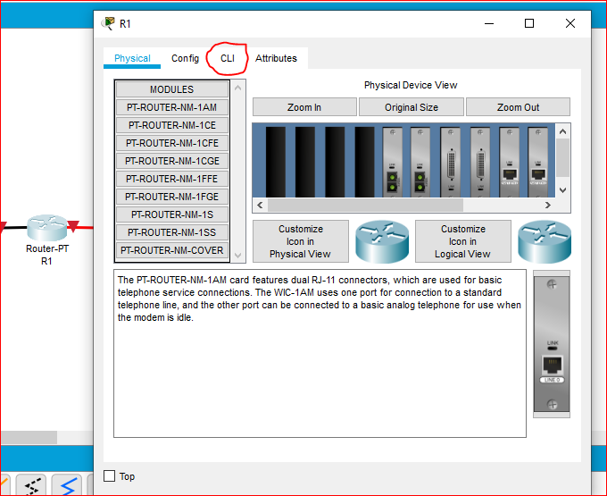

To start the configuration, click on the “CLI” tab which will open a configuration window similar to the one you see in Putty

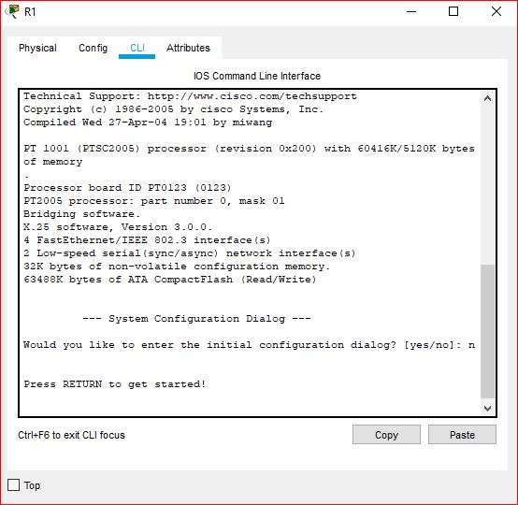

Press “RETURN” and get started.
The commands that you are used to using in the labs will be used here.
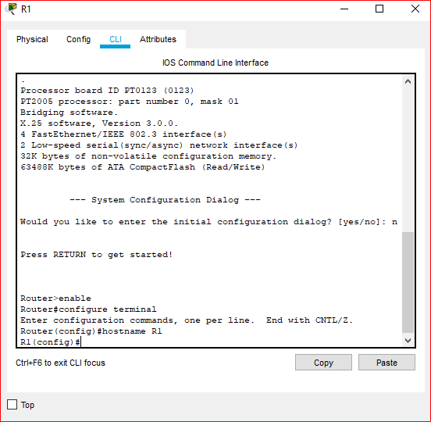
Let’s start by configuring the interfaces. Remember the interfaces can change. If you want to know the names of the interfaces give the command
show ip interface brief
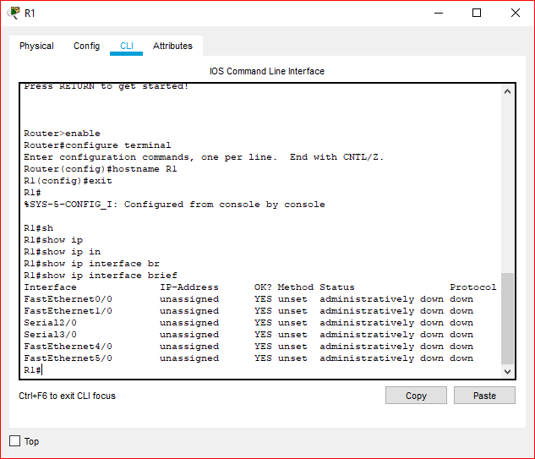
Configure the F0/0 interface
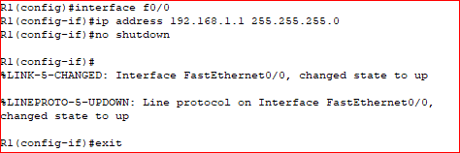
And the serial interface, please note R1 is the DCE in this instance and therefore needs a clock rate
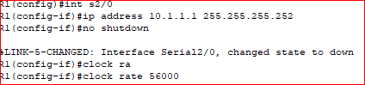
Configure R2
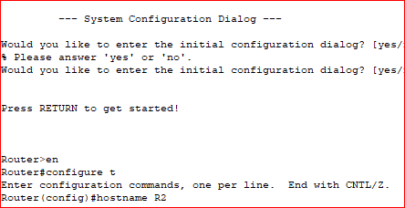
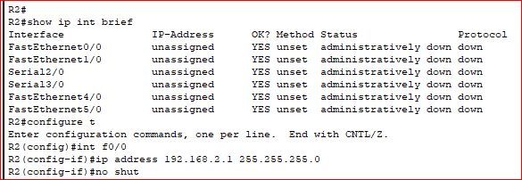
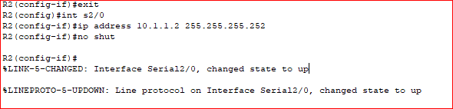

Note that all the links are now green, you can also check the status of your links by the “show ip interface brief “command

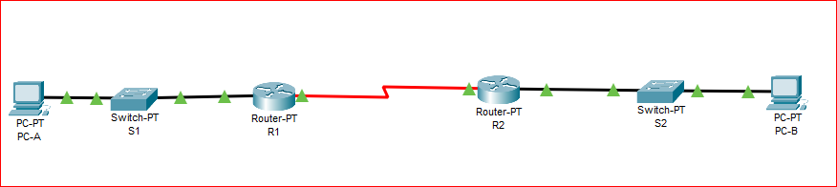
Let’s configure the routing as follow:
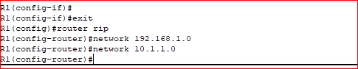
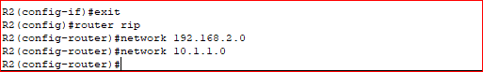
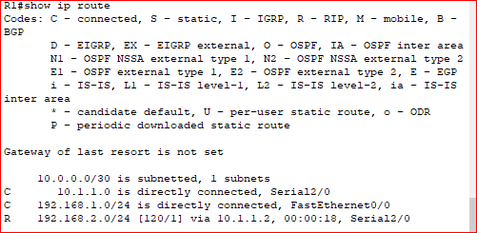

Let’s move to the PCs

Click on PC-A and then Desktop then open the IP Configuration
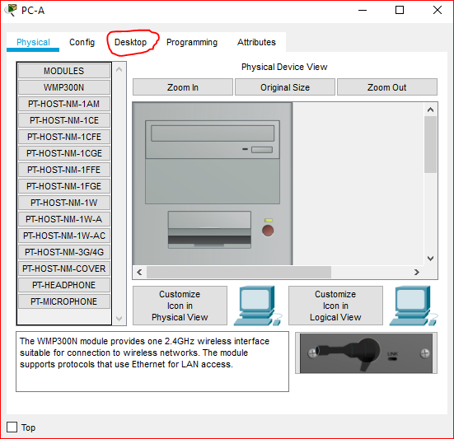
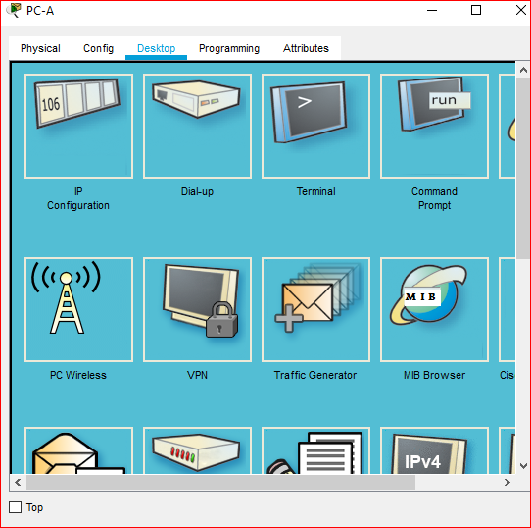
Enter the ip configuration: IP address, subnet mask and Default Gateway
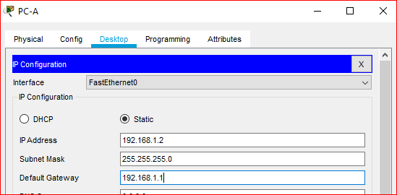
Do the same for PC-B
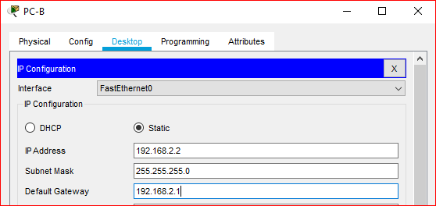
To test for end-to-end connectivity open the command prompt
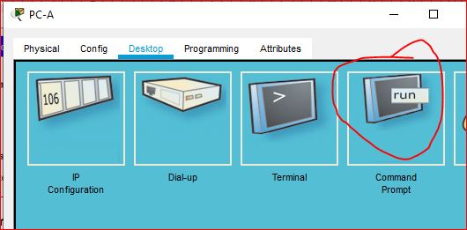
And do a normal ping

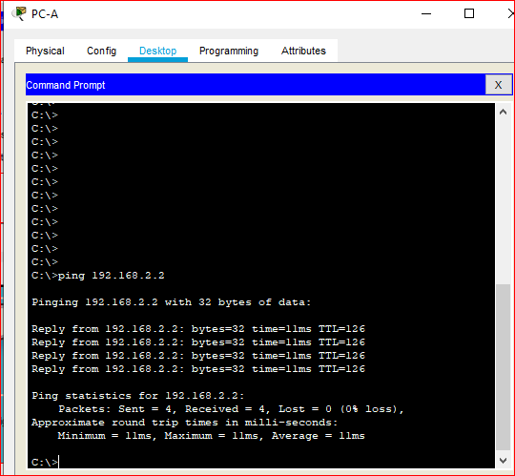

You can save your project and return to it at a later date, just click file and save/save as…

In the format of [your student number_ws number].pkt
E.g. 1947829_ws4.pkt
This will be uploaded to a gateway on canvas for each workshop

